Individual Lab Report #2

VIVEK GOPAL RAMASWAMY

**TEAM E- BEYOND SIGHT**

Team Members: Chien Chih Ho, Pengsheng Guo, Oliver Krengel, Rohit Murthy, Vivek Gopal Ramaswamy

20th October 2017



**Individual Progress:**

As a part of the team, I was responsible for interfacing ZED stereo Camera for getting the depth map of the environment. My secondary job included conducting trade studies for the NAS storage devices used for storing in the LIDAR data.

**ZED Camera:**

This is a passive stereo camera with two RGB cameras placed at a distance of 12 cm. The main reason for using passive stereo camera is that it can work outdoors also, as compared to the Kinect, which only works in an indoor environment.

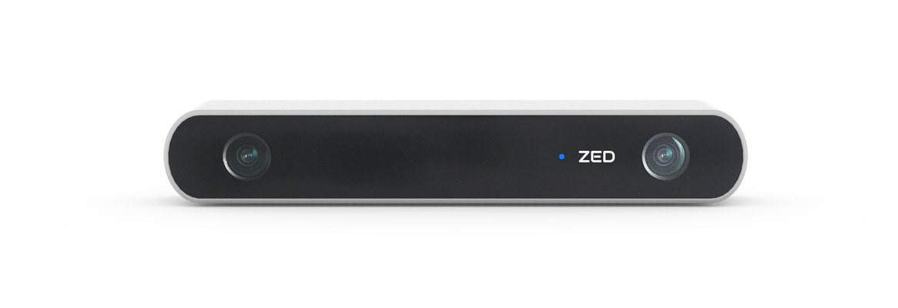

Fig 1. Zed Camera

Its key features [1] are as follows:

1. High-Resolution and High Frame-rate 3D Video Capture.
2. Depth Perception indoors and outdoors at up to 20m.
3. 6-DoF Positional Tracking.
4. Spatial Mapping.

**Setup:**

I followed the instruction manual [2] to setup the ZED camera in Linux environment. This required installation of CUDA and its dependencies and installation of the latest SDK for ZED. The GUI called the ZED explorer required an OpenCV support and to meet that, I installed the OpenCv3 as stated in the manual.

**NAS** (**Network Attached Storage**):

NAS is a high capacity storage device which gives multiple users access to a large amount of data. In our case, it will be the data from the LIDAR and the stereo camera.

The trade study [3] which I conducted was based on the following parameters:

1.NAS capacity.

2. Flexibility in accessing the data, remotely by multiple users.

3.Backup and Recovery.

4.Cost.

5. Flexibility in expanding.

Based on the above parameters, I had narrowed down the following NAS devices which are as follows:

|  |  |  |  |  |  |
| --- | --- | --- | --- | --- | --- |
| Name | Product | Cost($) | Backup | Expandability | Capacity Supported |
| **Synology DiskStation DS216j** | https://assets.pcmag.com/media/images/509358-synology-diskstation-ds216j.jpg?thumb=y&width=90&height=66 | 149 | Fixed Dual | No | 5.4 TB |
| **QNAP TAS-168** | https://assets.pcmag.com/media/images/509158-qnap-tas-168.jpg?thumb=y&width=90&height=66 | 181 | Fixed Single | No | 6 TB |
| **Synology DiskStation DS216+II** | https://assets.pcmag.com/media/images/552617-synology-diskstation-ds216-ii.jpg?thumb=y&width=90&height=66 | 269 | RAID | Yes | 10 TB |
| **Western Digital My Cloud Mirror Gen 2** | https://assets.pcmag.com/media/images/491913-wd-my-cloud-mirror-gen-2-4tb.jpg?thumb=y&width=90&height=66 | 300 | RAID | Yes | 8 TB |

After the trade study, I had found that the Synology Disk station is the one which matches closest to our requirements.

**Challenges**

The biggest challenge for me was to get the Zed camera installed in Linux. As per the team requirements, I was told to install the ZED only on Ubuntu version 14.04. Since the latest only supports 16.04 version, I had decided to look for a downgraded version for both the CUDA and the SDK.

Halfway through the installation process the system asks to disable the secure boot for the third party dependencies and once I do that, the gdm display device crashes and later the entire system gets corrupted.

I had gone through this process again and then finally decided to talk to my team, about the ZED camera’s compatibility issue on version 14.04.

Though I had not implemented it, the solution to this problem is to install the ZED in the ubuntu 16.04 version with OpenCV installed from the source and not from the links given in the ZED manual.

**Teamwork:**

**Vivek Gopal Ramaswamy:** Installation of ZED camera and conducting trade studies for NAS devices.

**Chien Chih Ho:** He was responsible for the generation of OctoMap and also for implementing background subtraction with Pengsheng Guo.

**Pengsheng Guo:** He was responsible for implementing background subtraction algorithm with Chien Chih Ho on the LIDAR data after filtering it from the leaf node.

**Oliver Krengel & Rohit Murthy:** They were responsible for assembling the mechanical cart with sensor mounts for LIDAR and ZED camera. Apart from that they also played a key role in getting the previous Team D’s car working.

**Current Project Progress and Future Plans**

For now, we have our mechanical cart assembled and mounted with LIDAR and ZED camera. Also, we have our LIDAR system with background subtraction implemented.

Our Future Plans include:

* Setting up the communication with ROS and the RC car.
* Getting depth map of the environment from ZED camera.
* Pedestrian detection using LIDAR.
* PCB schematic and design.

**References**

[1] [https://www.stereolabs.com/zed/specs/](https://www.pcmag.com/article2/0,2817,2401086,00.asp)

[2] [https://www.stereolabs.com/documentation/overview/getting-started/introduction.html](https://www.pcmag.com/article2/0,2817,2401086,00.asp)

[3] <https://www.pcmag.com/article2/0,2817,2401086,00.asp>